Algebra 1: Unit 6, Lesson 9

- Write the inequality that corresponds with the graph?
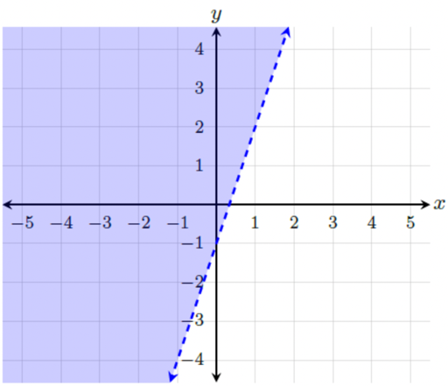
$$y>3x-1$$

- Two inequalities and their graphs are shown.
$$y≥-3x+7 \\ y< x-8$$
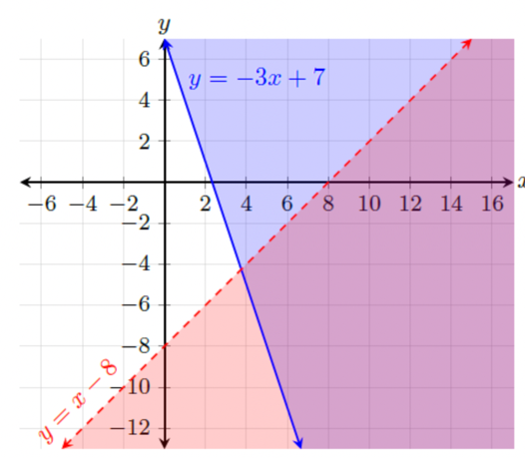
Determine whether the point $(4,-2)$ is a solution for both inequalities.
No, it is not a solution for both inequalities. Only one inequality.

- Two inequalities are shown.
$$y>x+2 \\ y≥2x+5$$Determine if the point $(-4, -1)$ is a solution for both inequalities.
Yes, it is a solution for both inequalities.

